**Web-based School Canteen Reservation Management System**

An Undergraduate Capstone Project Proposal

Presented to the

Panel of Examiners

Cebu Technological University

TABOGON EXTENSION

Poblacion, Tabogon, Cebu

In Partial Fulfillment

Of the Requirements for the Degree

BACHELOR OF SCIENCE IN INFORMATION TECHNOLOGY

Armenton, Jie Ar

Alagase, Kim Carlo P.

Flores, Arbejie

Inahid, Jonmar B.

Noynay, Aizaneth

Pacaldo, Junrel

Parco, Philip Dave P.

Sulad, Marjun

**CHAPTER I**

**The Problem and It’s Scope**

**Introduction**

**Project Context**

In the modern education landscape, school canteens play a vital role in providing students with nutritious meals and fostering a sense of community within educational institutions. As the number of students grows and dietary preferences diversify, the need for an efficient and user-friendly Web-based School Canteen Reservation Management System becomes increasingly apparent. This chapter aims to present a comprehensive overview of the problem at hand and outline the scope of our project. By addressing the challenges faced by both students and canteen staff, our system endeavors to streamline the reservation process, enhance food service, and contribute to a seamless and enjoyable dining experience.

The Web-based School Canteen Reservation Management System is designed to alleviate the struggles faced by students when reserving their meals and reduce the workload for canteen personnel. Existing manual reservation methods often result in long queues, time-consuming transactions, and food shortages, leading to frustration among students and staff alike. By implementing a digital reservation system, we aim to eliminate these inconveniences and ensure that students have access to their preferred meals with ease. Additionally, the system will empower canteen administrators with real-time insights and data to optimize food preparation, reduce waste, and cater to the evolving tastes of the student body.

This project aims to achieve several key objectives, centered around improving the overall canteen experience for students and staff. Firstly, the system will offer a user-friendly and intuitive interface that allows students to browse through a diverse menu, make reservations, and select convenient pick-up times. Secondly, it will enable canteen administrators to efficiently manage food inventory, track popular meal choices, and plan menus accordingly. By facilitating a smooth and organized reservation process, the system will foster a positive environment that encourages healthy eating habits and nurtures a sense of community within the school campus.

The scope of this project encompasses the development of a web-based application accessible to students and canteen personnel. The system will be designed to handle various types of meals, dietary preferences, and payment methods to cater to the diverse needs of the school community. While focusing on reservation and food management, the system will not include online payment processing, which will remain a separate module for future expansion. Moreover, data security and user privacy will be prioritized throughout the development process to safeguard sensitive information and ensure a trusted platform for all users.

In conclusion, the Web-based School Canteen Reservation Management System addresses the pressing challenges faced by educational institutions in managing their canteen operations efficiently. By harnessing the power of technology, we aspire to revolutionize the way students reserve and enjoy their meals, while empowering canteen administrators with data-driven insights for improved decision-making. As this chapter sets the context for our project, subsequent sections will delve into the system's design, development process, and implementation, providing a holistic understanding of our endeavor to create a seamless and user-friendly dining experience for the school community.

**Purpose and Description of the Project**

Our School Canteen Reservation Management System's main goal is to completely transform meals in educational settings. Our goal is to alleviate the typical difficulties that students and canteen employees encounter while making reservations and overseeing food service by utilizing technology. With a wide selection of options and various pick-up hours, our concept aims to give students a simple, quick way to make lunch reservations. By improving food inventory management, minimizing waste, and gathering useful information to improve menu planning, the technology also aims to lessen the strain on canteen administrators. The ultimate goal of this project is to cultivate a lively and welcoming school community where wholesome meal alternatives are readily available and the canteen.

A web-based program called the School Canteen Reservation Management System was created with the user's experience in mind. Students and staff may browse a sizable menu using an easy-to-use interface, and with the stroke of a button, they can easily reserve their chosen meals. To ensure a flawless and customized dining experience, the technology will let consumers tailor their orders based on dietary preferences and choose suitable pick-up hours. The system will give canteen managers real-time information on the most popular menu items, allowing them to plan and prepare meals more effectively and cut down on food waste and wait times. The initiative will put a strong emphasis on security and privacy, ensuring that user data is kept private and secure. We hope to develop a dynamic and effective system when we adopt this one.

**General Objectives**

The Web-based School Canteen Reservation Management System's major goal is to improve the dining experience for students and staff at the canteen. The system promises to decrease wait times, get rid of food shortages, and boost overall food service effectiveness by offering a user-friendly platform for meal reservations. The project also aims to equip canteen managers with useful information and data so they can improve menu planning, cut down on food waste, and accommodate the various dietary requirements of the student body. The ultimate goal is to establish a seamless and pleasurable dining environment that encourages wholesome eating habits, encourages social contact, and supports a lively and inclusive school community.

**Specific objectives**

* By establishing a user-friendly web-based application that enables students and staff to rapidly schedule their favorite meals, the reservation process will be streamlined and waiting times will be decreased.
* To increase the effectiveness of the food service by including a real-time inventory management system that gives canteen managers useful information about the most popular meals, allowing for better planning and fewer instances of food shortages.
* To accommodate a variety of dietary requirements by providing a flexible menu system that offers a large selection of wholesome and adequate food options for all students.
* To preserve user information, implement strong encryption and access controls, and abide by any data protection laws in order to maintain data security and privacy.
* By including a feedback tool that enables students and staff to give feedback on their dining experiences, it will be easier to increase communication between canteen personnel and patrons over time.
* By using data-driven analytics to determine consumption trends, allowing for better planning and eliminating surplus food production, it is possible to reduce food waste and maximize resource allocation.

**Scope and Delimitation**

**Scope**

* To provide a thorough system for managing reservations for school canteens that includes a user-friendly web-based application that is geared toward both students and staff and ensures effective meal reservations and order customization.
* To provide a variety of nutrient-dense food alternatives for the school community through the inclusion of a broad and adaptable menu system that takes into account different dietary preferences.
* To incorporate real-time inventory management, which would help canteen managers prepare food more efficiently, cut down on waste, and guarantee a sufficient supply of meals.
* To place a high priority on data security and privacy, enforcing strong encryption and access controls to secure user information and adhere to the necessary data protection laws.
* To create an interactive feedback method that invites staff and students to share comments on their dining experiences, promoting ongoing canteen service improvement.
* To provide a seamless transition to the digital platform and maximize the efficiency and benefits of the system by providing thorough training to canteen staff and users.
* To assess the effectiveness of the Web-based School Canteen Reservation Management System using performance indicators, user input, and data analytics, identifying opportunities for enhancement and potential growth in the future.

**Delimitation**

The Web-based School Canteen Reservation Management System will not include online payment processing. Payment methods will remain separate from the reservation platform.

**Significance of the Study**

The Web-based School Canteen Reservation Management System significantly enhances the dining experience by streamlining reservations, optimizing food service, ensuring data security, and fostering a vibrant canteen community.

**Efficient Reservation Process:**

The implementation of the Web-based School Canteen Reservation Management System holds significant value in enhancing the efficiency of the reservation process. By providing a user-friendly web-based application, students and staff can conveniently browse through a diverse menu, customize their meal orders, and reserve preferred items effortlessly. This streamlined reservation system reduces waiting times, eliminates long queues, and ensures that every member of the school community can access their desired meals without any hassle.

**Optimized Food Service:**

The proposed system's real-time inventory management feature offers considerable benefits to canteen administrators. By analyzing data on popular meal choices, the system empowers administrators to make informed decisions about menu planning, ensuring an adequate supply of meals while minimizing food waste. This optimization not only leads to cost savings but also fosters a more sustainable approach to food service within the school.

**Improved Communication and Feedback:**

The inclusion of an interactive feedback mechanism in the proposed system provides valuable insights for canteen administrators. Students and staff can share their dining experiences, preferences, and suggestions, leading to continuous improvements in the quality of canteen services. This direct line of communication helps administrators adapt to changing preferences, address concerns promptly, and foster a sense of community within the school canteen environment.

**Enhanced Accessibility and Flexibility:**

The web-based nature of the School Canteen Reservation Management System grants users the flexibility to access the platform from any location with an internet connection. This enhanced accessibility allows students and staff to make reservations at their convenience, even outside the school premises. As a result, the canteen becomes a more dynamic and inclusive space, catering to the varying schedules and preferences of the entire school community.

**Promotion of Healthy Eating Habits:**

With the system's customizable menu that caters to diverse dietary preferences, the proposed project encourages and promotes healthier eating habits among students and staff. By offering nutritious meal options, the canteen becomes an environment that supports overall well-being and academic performance.

**CHAPTER II**

This chapter presents a comprehensive review of the existing literature on reservation systems and food service management within educational institutions. Scholars have explored various theories and approaches to streamline reservation processes, improve data reporting systems, and enhance overall management efficiency. The studies highlight the significance of secure data handling, open communication channels, and data-driven decision-making in creating a user-friendly and effective canteen reservation system. By synthesizing these findings, our School Canteen Reservation Management System aims to build upon existing knowledge and develop a robust platform that optimizes food service, fosters a vibrant canteen community, and ensures a seamless dining experience for students and staff.

**Related Systems**

Web-based Food Ordering Systems have been developed to cater to the increasing demand for efficient and user-friendly reservation management in various industries, including educational institutions. These systems provide a convenient online platform for students and staff to reserve meals from the school canteen. Depending on their preferences and dietary requirements, customers can instantly view the available menu options and select their desired meals. The system's architecture comprises different modules, leveraging technology to streamline the reservation process and enhance the overall dining experience. With a user-centric approach, these platforms allow canteen administrators to manage food inventory more effectively, reduce waiting times, and optimize food preparation. Furthermore, the system empowers customers by enabling them to access the platform from anywhere with an internet connection, providing flexibility and ease of use. By incorporating secure data handling and communication features, web-based school canteen reservation systems ensure that user information remains confidential, fostering a trusted and efficient reservation management process.

**Related Study Projects**

This research project, conducted in Cebu Technological University, aimed to explore the impact of implementing a Web-based School Canteen Reservation Management System on the dining experience and food service efficiency within the educational institution. Guided by user-centric design principles, the study employed a mixed-methods approach to gather data from students, staff, and canteen administrators of Cebu Technological University. Structured questionnaires and interviews were the main data collection tools, ensuring a comprehensive understanding of user preferences and challenges in the current reservation process at the university's canteen. Data analysis included descriptive statistics to examine reservation patterns and qualitative analysis to gain insights into user feedback and expectations. The study revealed that the implementation of the Web-based Reservation System significantly reduced waiting times, improved food inventory management, and empowered users to personalize their meal orders based on dietary preferences. The findings emphasized the importance of data security and privacy, ensuring that user information remains confidential. Overall, the research indicated a positive impact on the dining culture, fostering a vibrant and inclusive canteen community within Cebu Technological University. Based on the study's recommendations, the Web-based School Canteen Reservation Management System promises to enhance the overall dining experience, optimize food service, and cater to the diverse needs of the school community at Cebu Technological University.

**Foreign Study Projects**

**Title:** Streamlining Dining Services: A Comparative Analysis of Web-based School Canteen Reservation Management Systems in European Universities

**Abstract:**

This cross-sectional study aims to compare and evaluate the implementation of Web-based School Canteen Reservation Management Systems in various European universities. Using a combination of surveys and focus group discussions, data will be collected from students, faculty, and canteen administrators to assess the systems' effectiveness in reducing waiting times, optimizing food service, and meeting the dietary preferences of diverse campus communities. The research seeks to identify best practices and challenges faced by different institutions, providing valuable insights into enhancing the dining experience across European universities.

**Title:** Improving Campus Food Services: An Investigation of Web-based Canteen Reservation Systems in Australian Educational Institutions

**Abstract:**

This research project aims to explore the impact of Web-based School Canteen Reservation Management Systems on campus food services in Australian educational institutions. Through qualitative interviews and observations, data will be collected from students, staff, and canteen operators to assess the systems' user-friendliness, efficiency, and ability to accommodate dietary requirements. The study seeks to identify factors that contribute to successful implementation and examine how these systems enhance the overall dining experience in diverse Australian campuses, providing valuable insights for other institutions seeking to upgrade their food service management.

**Title:** Enhancing Dining Accessibility: A Case Study of Web-based School Canteen Reservation Management System in a Leading North American University

**Abstract:**

This case study investigates the implementation of a Web-based School Canteen Reservation Management System in a prominent North American university. Combining qualitative surveys and usability testing, the study will gather data from students, faculty, and canteen administrators to evaluate the system's impact on reducing wait times, facilitating dietary customization, and fostering inclusivity in the campus dining experience. The research aims to identify user preferences and areas for improvement, contributing valuable insights for other educational institutions in North America seeking to implement similar systems to enhance their canteen services and student satisfaction.

**Chapter III**

**TECHNICAL BACKGROUND**

**Technicality of the Project**

The Web-based School Canteen Reservation Management System is a comprehensive and user-friendly platform designed to efficiently handle day-to-day reservation transactions and provide comprehensive management information for educational institutions. The system is specifically tailored to meet the unique requirements of schools and universities with dining facilities. It facilitates the storage of crucial information for registered users, including students, staff, and canteen administrators. For users, the system allows convenient reservation of meals, enabling them to select from a diverse menu. On the administrator's side, the system offers full control over managing reservation records and food inventory in the database.

The technical implementation of the system involves a logical Database Design for the relational model, ensuring a structured and organized database schema. The Physical Database design is derived by translating the logical data model into a robust and scalable MySQL Database Management system, enabling efficient data storage and retrieval. The system architecture leverages modern web technologies, such as HTML, CSS, and JavaScript, to create a responsive and user-friendly interface accessible from various devices.

Key functionalities of the Web-based School Canteen Reservation Management System include:

1. User Registration and Profile Management: The system enables users to create and maintain their profiles, providing essential information for identification and reservation purposes.

2. Reservation: Users can access the menu, and make reservations for preferred items within the specified time frames.

3. Inventory Management: The system helps canteen administrators manage food inventory by tracking the availability of menu items, preventing overbooking or shortages.

4. Data Security and Privacy: Stringent security measures, such as encryption and access controls, ensure the confidentiality of user information and protect sensitive data from unauthorized access.

Overall, the Web-based School Canteen Reservation Management System offers a seamless and efficient reservation process, promoting a positive dining experience for the school community while providing administrators with effective tools for managing canteen operations and enhancing overall service quality.

**Software Specification**

**Software**

Operating system

Software

Database

**Specification**

Windows or Linux

XAMPP, TEXT EDITORS, BROWSERS

MySQL

**System Architecture**

The System Architecture of the Web-based School Canteen Reservation Management System was developed based on the requirements gathered from interviews, observations, and discussion groups. The architecture encompasses various components, with a primary focus on the database, which plays a crucial role in storing and managing information about users who apply for reservations. The system efficiently cross-checks for repetitions and creates a comprehensive summary of the reservation data for each user.

The architectural design follows a systematic approach, starting from the fundamental level of entities and their attributes, then establishing relationships between entities, leading to the creation of an entity relationship diagram (ERD). The ERD serves as a blueprint for the logical Database Design, outlining the structure and organization of the relational model.

For the physical implementation, the logical data model is translated into the MySQL Database Management system, which offers robust and scalable data storage capabilities. MySQL ensures efficient data management, enabling seamless data retrieval and manipulation for smooth reservation processes.

The prototype of the system was meticulously designed to meet the basic requirements of the users. Throughout the development process, user feedback was incorporated, ensuring the prototype aligned with their needs and preferences. As a result, the working system successfully met the fundamental user requirements, providing a user-friendly and efficient platform for reserving meals at the school canteen.

In conclusion, the System Architecture of the Web-based School Canteen Reservation Management System is well-structured, utilizing a logical and relational data model, and implemented on the MySQL Database Management system. This ensures the system's reliability, performance, and scalability, providing a seamless and effective reservation experience for the school community.

**Details of the Technology to be Used:**

1. **Hyper-Text Transfer Protocol (HTTP):**

HTTP is a set of rules for transferring files, including text, images, sound, video, and other multimedia files, over the web. It is the underlying protocol used when users open their web browsers to access websites.

2. **Apache:**

Apache is an open-source web server software that serves as the foundation for hosting websites and applications. It is part of the group of American Indian peoples in the southwestern U.S., but in the context of technology, it refers to the web server software.

3. **MySQL:**

MySQL is an open-source relational database management system (RDBMS) used to store, manage, and retrieve data. Its name is a combination of "My," the name of co-founder Michael Widenius's daughter, and "SQL," which stands for Structured Query Language.

4. **Cascading Style Sheet (CSS):**

CSS is a stylesheet language that defines the presentation of a web document written in HTML or XML. It determines how elements should be rendered on various media, such as screens, paper, or speech.

5. **Hypertext Preprocessor (PHP):**

PHP is a scripting language used to create dynamic and interactive HTML web pages. It is executed on the server, processing PHP commands and sending the results to the visitor's browser.

6. **JavaScript:**

JavaScript is a scripting language primarily used on the web to enhance HTML pages and add interactivity. It is embedded in HTML code and executed by the browser to render web pages dynamically.

7. **Hypertext Markup Language (HTML):**

HTML is the fundamental building block of the web. It defines the structure and meaning of web content, while other technologies like CSS and JavaScript handle appearance and functionality, respectively.

**How the project will work**

The Web-based School Canteen Reservation Management System operates through a well-structured and user-centric approach. The project commences with in-depth interviews, observations, and discussions to understand the existing challenges and requirements within the school's canteen management. Through this data gathering process, the researchers identify key issues faced by students, staff, and canteen administrators during the reservation process.

Using the valuable insights from the initial phase, the researchers proceed to design a comprehensive solution in the form of the Web-based School Canteen Reservation Management System. This system is custom-built to cater specifically to the unique needs of the educational institution, ensuring seamless reservation experiences for all users.

The heart of the system lies in its user-friendly interface, which allows students and staff to effortlessly access the canteen's menu, customize their meal choices, and make reservations within specified time frames. On the administrator's side, the system empowers canteen staff with efficient tools for managing food inventory, monitoring reservations, and generating insightful reports on reservation patterns.

To ensure data security and privacy, the system employs robust measures to protect user information and prevent unauthorized access. Throughout the development process, the researchers prioritize iterative user testing and feedback collection to fine-tune the system, making continuous improvements to meet the ever-evolving needs of the school community.

Upon completion, the Web-based School Canteen Reservation Management System aims to revolutionize the dining experience within the educational institution, streamlining operations, reducing waiting times, and fostering an inclusive and vibrant canteen community. The project's success will ultimately be measured by the increased efficiency and overall satisfaction of users, creating a positive impact on the dining culture and enhancing the overall campus experience.

**Chapter IV**

**MATERIALS AND METHODS**

**Environment**

The Web-based School Canteen Reservation Management System has been successfully implemented at Cebu Technological University. Specifically designed to cater to the needs of students, faculty, and staff within the university, the system efficiently stores and manages reservation records for the canteen. It provides a seamless reservation experience for the university community, allowing them to access the canteen's menu, and make reservations within the campus premises. The system serves as a central hub for managing food inventory, monitoring reservation patterns, and generating insightful reports for canteen administrators at Cebu Technological University.

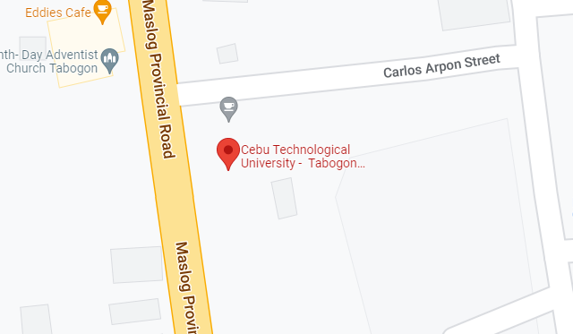

**Descriptions and functions**

The Web-based School Canteen Reservation Management System is a comprehensive platform designed to enhance the dining experience within Cebu Technological University. It efficiently manages canteen reservations, streamlining the process for students, faculty, and staff. The system ensures a seamless and user-friendly reservation process, catering to diverse dietary preferences and optimizing food service operations.

**Key Functions:**

1. Reservation Recording: The system efficiently records every canteen reservation made by students, faculty, and staff. It captures essential details, such as date, time, and meal preferences, providing a centralized database of reservation records.

2. Real-time Transaction Monitoring: With the Web-based Reservation Management System, canteen administrators can monitor reservations in real-time. This feature enables administrators to track reservation patterns, analyze peak hours, and make data-driven decisions to optimize food service efficiency.

3. User-Friendly Interface: The system boasts an intuitive and user-friendly interface, enabling easy navigation for users. Students, faculty, and staff can effortlessly access the system, view the menu, and make reservations with a few clicks

4. Admin Control: The system grants administrators’ full control over its functionalities. Admins can manage user profiles, monitor reservation records, and generate insightful reports on reservation patterns and food preferences.

5. Data Security: Ensuring data security and privacy is paramount. The system incorporates robust encryption protocols to safeguard user information and prevent unauthorized access.

In conclusion, the Web-based School Canteen Reservation Management System is a powerful tool that optimizes the canteen reservation process within Cebu Technological University. By offering user-friendly functionalities, seamless reservations, and efficient inventory management, the system aims to foster a vibrant and inclusive canteen community, elevating the overall dining experience for all stakeholders involved.

**Location or Address**

Poblacion, Tabogon, Cebu

**Problems Encountered**

1. Inaccurate Records: The existing manual reservation system faced challenges in maintaining accurate and up-to-date records. Human errors during data entry or record management led to discrepancies in reservation information, impacting the overall efficiency of the canteen operation.

2. Unreadable Handwritten: The reliance on handwritten reservation records posed readability issues, causing confusion and misinterpretation of reservation details. Illegible handwriting made it difficult to retrieve and verify reservation data, leading to potential reservation conflicts and delays.

**Proposed Improvements (to-be-system):**

The proposed Web-based School Canteen Reservation Management System seeks to address these problems effectively by introducing a modern, technology-driven solution. As staff members transition to the digital landscape, the system eliminates the challenges associated with inaccurate records and unreadable handwritten notes. By adopting the new system, staff members become more tech-savvy, embracing the benefits of streamlined processes and enhanced accuracy in reservation management.

The Web-based Reservation System empowers staff with user-friendly interfaces, allowing them to efficiently record, manage, and access reservation data. Automated data entry and digital record-keeping reduce the risk of inaccuracies, ensuring that reservation information remains up-to-date and consistent.

Moreover, the system eliminates the need for handwritten notes, providing a clear and legible platform for reservation entries. This enhancement promotes clarity and accuracy in reservation details, eliminating the possibility of misinterpretation and ensuring smooth reservation transactions.

By embracing technology and transitioning to the proposed system, staff members at Cebu Technological University's canteen will experience increased efficiency, reduced errors, and improved overall service quality. The adoption of the Web-based School Canteen Reservation Management System marks a significant step towards a more streamlined and modernized reservation process, creating a seamless and enjoyable dining experience for the entire university community.

**Business Process:**

The Web-based School Canteen Reservation Management System is proposed and recommended for implementation at Cebu Technological University to revolutionize their canteen management process. By adopting the proposed system, the university can efficiently manage canteen reservations and enhance overall dining experiences for students, faculty, and staff.

**Figure 9. Usefulness in Developing SCA:**

1. Clarity Requirements: The proposed system requires users to register their personal information to create an account. This ensures clarity and accuracy in recording reservation details, providing a comprehensive database of reservation records.

2. Familiarity with the Technology: To use the Web-based School Canteen Reservation Management System, users are not required to have advanced technical knowledge. The system boasts an intuitive and user-friendly interface, enabling easy navigation and interaction for all users.

3. System Complexity: The system is designed to be user-friendly, allowing students, faculty, and staff to make reservations seamlessly with a laptop or computer and a stable internet connection. With minimal technical requirements, users can enjoy a hassle-free reservation experience.

4. System Reliability: The proposed reservation management system guarantees reliability and security. It efficiently stores and safeguards reservation data, ensuring the confidentiality and privacy of user information.

By implementing the Web-based School Canteen Reservation Management System, Cebu Technological University can elevate their canteen management processes, optimize food service operations, and foster an inclusive and vibrant canteen community. The system's user-centric approach enhances the overall dining experience, creating a positive impact on campus life for the entire university community.

**STAFFING PLAN**

**Project Manager**

**Technical Head**

**Functional Head**

**Analyst 2**

**Analyst 1**

**Figure 10. Staffing Plan**

|  |  |  |
| --- | --- | --- |
| **Project Manager** | Monitors the project to ensure it reaches its goals and on budget. | **Rico T.Gulben** |
| **Functional Head** | Checks that the systems suggested meet the end users’ expectations and needs. | **Fatima R. Saladaga/** **Joris A. Coyoca** |
| **Technical Head** | Track the systems compliance with end users’ specification and requirements. | **Regie S. Tagulaylay/** **Arlou R. Urot** |
| **Analyst 1** | Designs the record keeping system based on the data flow. | **Rossie P. Medillo** |
| **Analyst 2** | Designs the UI of the system. | **Jessen E. Jayme** |

**Table 2. Roles and Description of the system.**

**Working days: 70 Days**

|  |  |
| --- | --- |
| **STANDARD** | **ACTUAL** |
| **Planning Days** | **10 Days** |
| **Analysis Days** | **10 Days** |
| **Design Days** | **20 Days** |
| **Implementation Days** | **30 Days** |
| **Total Days** | **100 Days** |
|  |  |

**Table 3. Working Days (Project Time Frame)**

**Requirement Definition**

**Functional Requirements:**

The functional requirements of the Web-based School Canteen Reservation Management System encompass its intended behavior and the services it provides. The system is designed to register and store all reservation information, facilitating a smooth and efficient reservation process for users.

**Non-functional Requirements:**

In addition to specific behavior and functions, the Web-based School Canteen Reservation Management System adheres to various non-functional requirements that govern its overall performance and reliability. These include:

• **Sufficient Resources**: The system is equipped with ample processor speed, memory, disk space, and network bandwidth to ensure optimal performance and responsiveness.

• **Good Performance**: The system demonstrates excellent response times and run time, enabling swift and seamless reservation processing for users.

• **High Availability:** The system is designed to be available at all times, ensuring uninterrupted access to reservation services.

• **Maintainability**: The system is structured and organized in a way that facilitates easy maintenance and updates, ensuring long-term sustainability.

• **Scalability**: The system can handle multiple users simultaneously, accommodating a growing number of users without compromising on performance.

• **Reliability**: The system is highly reliable, minimizing the mean time between failures and providing a stable and consistent reservation platform.

• **Security Mechanism:** The system implements robust security measures to authenticate authorized users and protect against unauthorized access, ensuring data confidentiality.

The adherence to these non-functional requirements ensures that the Web-based School Canteen Reservation Management System delivers a reliable, secure, and user-friendly experience, supporting the canteen community at Cebu Technological University effectively and efficiently.

**Requirement Analysis Strategies**

**Problem Analysis**

The current reservation management system at Cebu Technological University's canteen is manual and paper-based, leading to inefficiencies, poor records keeping, and long queues. To address these issues and enhance the overall reservation process, a web-based school canteen reservation management system is proposed. This digital solution aims to streamline reservation processes, improve record-keeping efficiency, and provide a user-friendly experience for students, faculty, and staff. The transition to a web-based system promises to modernize and optimize the canteen's operations, creating a more efficient and seamless dining experience for the university community.

**Work Breakdown Structure**

|  |  |  |  |  |  |
| --- | --- | --- | --- | --- | --- |
| **Task Name** | **Start Date** | **Finish Date** | **Duration (Days)** | **Persons Involved** | **Predecessor Task** |
| **Project Planning Phase** | 04/18/22 | 04/28/22 | 10 Days | A, B, C, D, E, F, G |  |
| 1.1 Project Identification and Initiation | 04/18/22 | 04/19/22 | 1 Day | A, B, C, D, E, F, G |  |
| 1.2 System Request | 04/19/22 | 04/20/22 | 1 Day | A, B, C, D, E, F, G | 1.1 |
| 1.3 Feasibility Study | 04/20/22 | 04/21/22 | 1 Day | A, B, C, D, E, F, G | 1.2 |
| 1.3.1 Technical | 04/21/22 | 04/22/22 | 1 Day | A, B, C, D, E, F, G | 1.3 |
| 1.3.2 Economic | 04/22/22 | 04/23/22 | 1 Day | A, B, C, D, E, F, G | 1.3.1 |
| 1.3.3 Organizational | 04/23/22 | 04/24/22 | 1 Day | A, B, C, D, E, F, G | 1.3.2 |
| 1.4 Development Methodology | 04/24/22 | 04/25/22 | 1 Day | A, B, C, D, E, F, G | 1.3.3 |
| 1.5 Project Time Frame | 04/25/22 | 04/26/22 | 1 Day | A, B, C, D, E, F, G | 1.4 |
| 1.6 Staffing Plan | 04/26/22 | 04/27/22 | 1 Day | A, B, C, D, E, F, G | 1.5 |
| 1.7 Work Plan | 04/27/22 | 04/28/22 | 1 Day | A, B, C, D, E, F, G | 1.6 |
| **Analysis phase** | 04/28/22 | 05/08/22 | 10 Days | A, B, C, D, E, F, G | 1.7 |
| 2.1 Functional and Non-functional requirements | 04/28/22 | 04/29/22 | 2 Days | A, B, C, D, E, F, G | 2 |
| 2.1.1 Functional requirements | 04/29/22 | 05/01/22 | 2 Days | A, B, C, D, E, F, G | 2.1 |
| 2.1.2 Non-functional requirements | 05/01/22 | 05/03/22 | 2 Days | A, B, C, D, E, F, G | 2.1.1 |
| 2.2 Requirements Elicitation Techniques | 05/03/22 | 05/05/22 | 2 Days | A, B, C, D, E, F, G | 2.1.2 |
| 2.3 Requirement Analysis Strategies | 05/05/22 | 05/07/22 | 2 Days | A, B, C, D, E, F, G | 2.2 |
| **Design Phase** | 05/07/22 | 05/27/22 | 20 Days | A, B, C, D, E, F, G | 2.3 |
| 3.1 Design Strategy | 05/07/22 | 05/11/22 | 4 Days | A, B, C, D, E, F, G | 3 |
| 3.2 Design the architecture of the system | 05/11/22 | 05/15/22 | 4 Days | A, B, C, D, E, F, G | 3.1 |
| 3.3 Design hardware and software selections | 05/15/22 | 05/19/22 | 4 Days | A, B, C, D, E, F, G | 3.2 |
| 3.4 Design Database and file specification | 05/19/22 | 05/23/22 | 4 Days | A, B, C, D, E, F, G | 3.3 |
| 3.5 Design system navigation inputs and outpust | 05/23/22 | 05/27/22 | 4 Days | A, B, C, D, E, F, G | 3.4 |
| **Implementation phase** | 05/27/22 | 06/28/22 | 30 Days | A, B, C, D, E, F, G | 3.5 |
| 4.1 Developing the system | 05/27/22 | 05/29/22 | 2 Days | A, B, C, D, E, F, G | 4 |
| 4.1.1 Assigning programming tasks | 05/29/22 | 05/30/22 | 1 Day | A, B, C, D, E, F, G | 4.1 |
| 4.1.2 Coordinating activities | 05/30/22 | 06/01/22 | 1 Day | A, B, C, D, E, F, G | 4.1.1 |
| 4.1.3 Managing schedule | 06/01/22 | 06/03/22 | 2 Days | A, B, C, D, E, F, G | 4.1.2 |
| 4.2 Testing the system | 06/03/22 | 06/04/22 | 1 Day | A, B, C, D, E, F, G | 4.1.3 |
| 4.2.1 Test Planning | 06/04/22 | 06/06/22 | 2 Days | A, B, C, D, E, F, G | 4.2 |
| 4.2.2 Unit Test | 06/06/22 | 06/08/22 | 2 Days | A, B, C, D, E, F, G | 4.2.1 |
| 4.2.3 Integration Tests | 06/08/22 | 06/10/22 | 2 Days | A, B, C, D, E, F, G | 4.2.2 |
| 4.2.4 System Testing | 06/10/22 | 06/12/22 | 2 Days | A, B, C, D, E, F, G | 4.2.3 |
| 4.2.5 Acceptance Testing | 06/12/22 | 06/14/22 | 2 Days | A, B, C, D, E, F, G | 4.2.4 |
| 4.3 Documentation | 06/14/22 | 06/16/22 | 2 Days | A, B, C, D, E, F, G | 4.2.5 |
| 4.3.1 System Documentation | 06/16/22 | 06/18/22 | 2 Days | A, B, C, D, E, F, G | 4.3 |
| 4.3.2 User Documentation | 06/18/22 | 06/20/22 | 2 Days | A, B, C, D, E, F, G | 4.3.1 |
| 4.4 Operating Procedures | 06/20/22 | 06/22/22 | 2 Days | A, B, C, D, E, F, G | 4.3.2 |
| 4.4.1 Reference | 06/22/22 | 06/24/22 | 2 Days | A, B, C, D, E, F, G | 4.4 |
| 4.4.2 Procedures Manuals | 06/24/22 | 06/26/22 | 2 Days | A, B, C, D, E, F, G | 4.4.1 |
| 4.4.3 Tutorials | 06/26/22 | 06/28/22 | 2 Days | A, B, C, D, E, F, G | 4.4.2 |

**Chapter V**

**USER INTERFACE DESIGN**

**HTML PROTOTYPE**

**LOG-IN PAGE**

This is the log-in page wherein the users of the system will log-in using their own credentials such as their email and password in order to access the system.

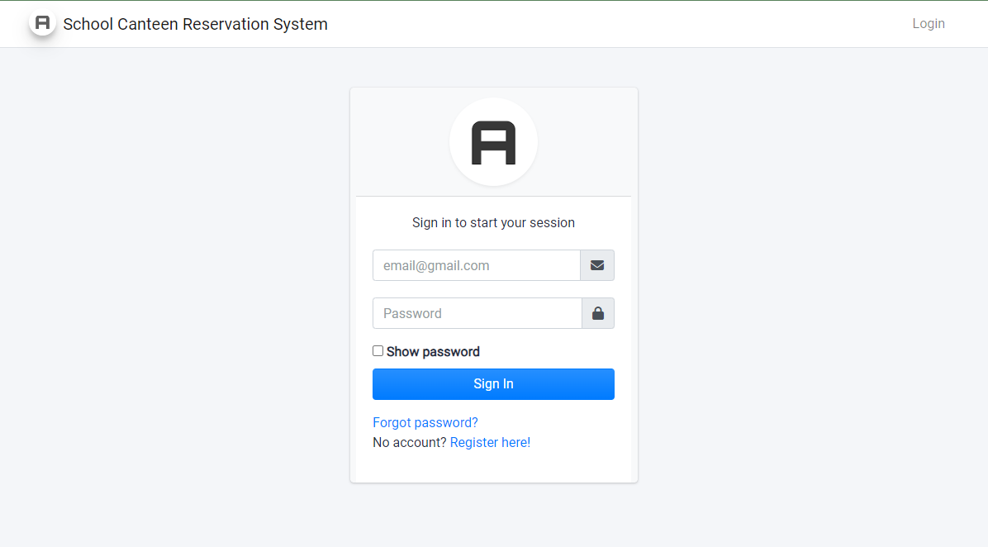

**FORGOT PASSWORD PAGE** To search for an email of the user who forgets his/her password.

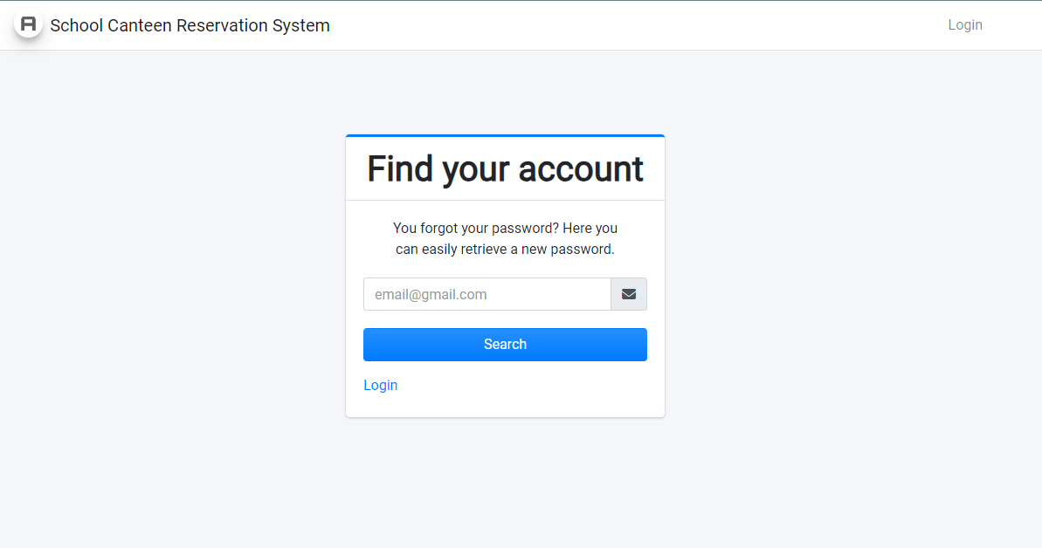

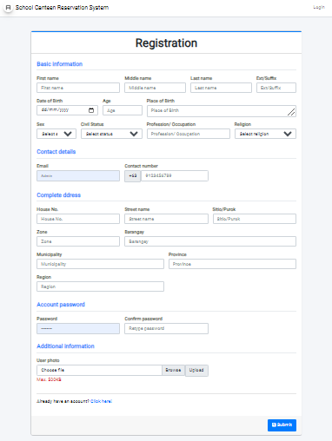**USER REGISTRATION** To access the system, students will have to register to create their accounts.

**DASHBOARD**

The dashboard display the number of records of the users, administrators and other necessary records.

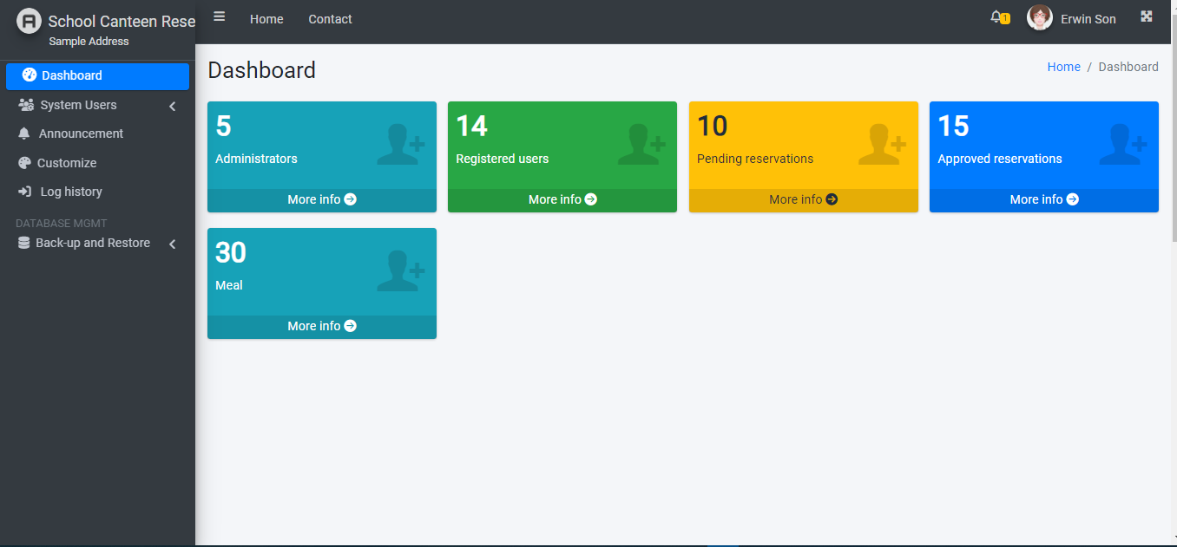

**USER RECORDS**

This page shows all the user/students/teachers records who registered into the system.

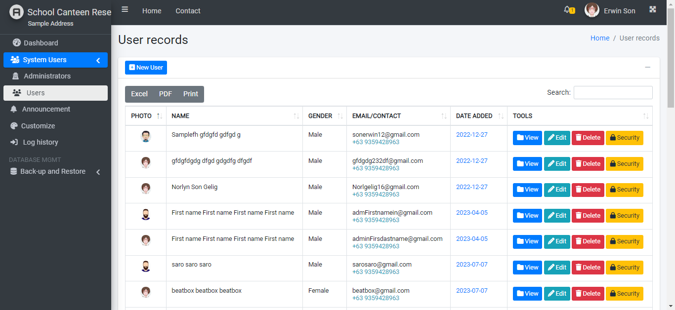

**ADMINISTRATOR RECORDS**

This page shows all the system administrators that controls the system information.

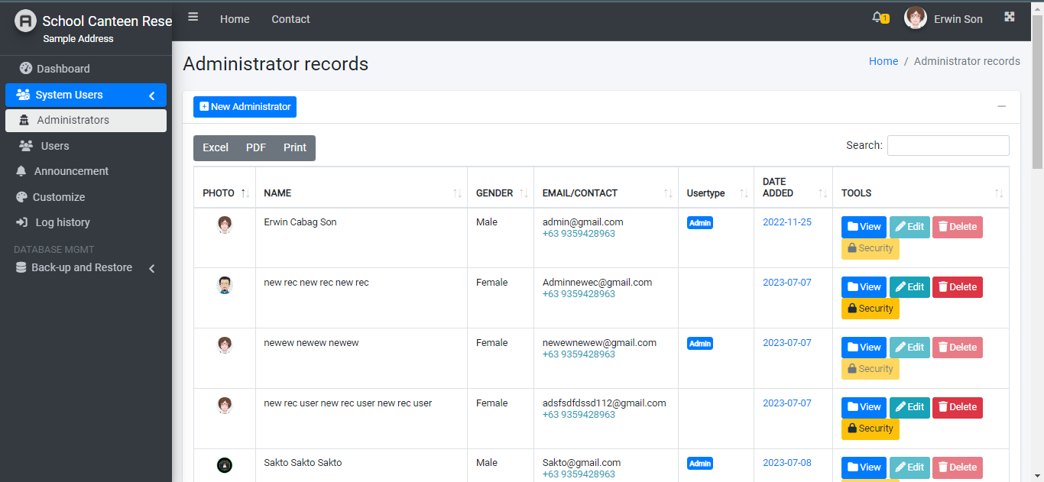

**LOG HISTORY**

In this page, the logged in user can see his/her log history  
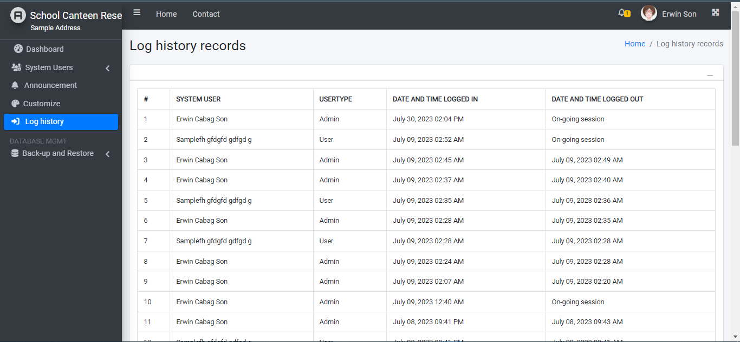

**PROFILE**

The logged in user can view and update his/her information in the system. He/she can also change his/her password for better security.

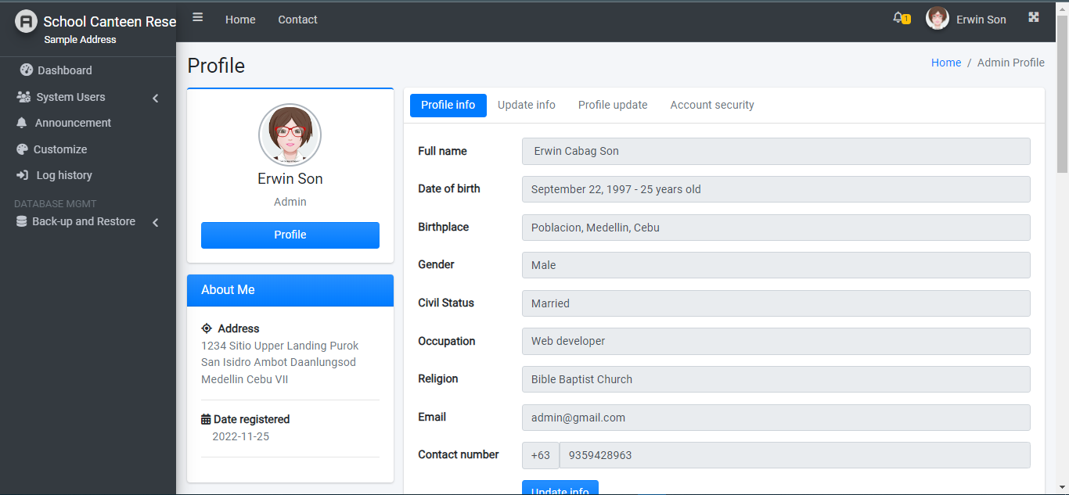

**LOGOUT**

This modal will only show up when the logged in user wants to exit from the system.  
